Qualification details
Training Package Code and Title | ICT - Information and Communications Technology (Release 8.1)
Qualification National Code and Title | ICT50220 Diploma of information Technology (Release 2) | State code | BGJ4
Assessment Title  (as per DAP) | Assessment Task 1
Unit National Code & Title | ICTPRG443 Apply intermediate programming skills in different languages |  | OBT13
Unit National Code & Title | ICTICT430 Apply software development methodologies |  | OBU02
Unit National Code & Title | ICTICT523 Gather data to identify business requirements |  | OBU27
Date Due | Week 10 |  | Date Received
Student Name | SUNJU CHOI
Student Declaration | I declare that the evidence submitted is my own work:
Assessor Name
Assessment Decision | ☐ Satisfactory |  |  | ☐ Not Yet Satisfactory
Assessor Signature |  |  |  | Date
Is student eligible for reassessment (Re-sit)? | ☐No | ☐Yes |  | Re-assessment Date: |  | Week Nineteen
Feedback to student
Via Blackboard (LMS) – Please check [Grade] section.

Feedback from student
Via Blackboard (LMS) – Please use [Comment] section during submission.

Student signature |  | Date

Assessment Instructions
TO THE ASSESSOR
Type of Assessment | Individual Portfolio
Duration of the assessment | 10 class sessions (Weeks 1-10)
Location of assessment | Classroom
Conditions | Assessor to ensure that the noise levels, natural interactions and time variances are maintained as it would be in the Software Development industry.  Learners are required to complete the required tasks in class and submit the required documentation electronically via Blackboard
Elements and Criteria | As detailed in the assessment plan  You are required to make sure that all students meet the elements, performance criteria and oral communication items as outlined in the provided solution
TO THE STUDENT
Purpose of Assessment | You are required to show you can:  - Carry out intermediate programming activities, such as coding, debugging, testing, and creating applications.  - Use a traditional and non-traditional development methodologies for application development.  - Identify, analyse, and document business requirements according to project requirements.  The student must demonstrate the ability to complete the tasks outlined in this assessment and is expected to use systematic analytical processes and effect time management to meet the goals/deadlines outlined in the DAP.

Allowable Materials | Blackboard Topics: SDLC, Weekly readings (PDF), Example programs and Independent Outside of Class Activities
Required Resources | Web links and example code can be downloaded from the Blackboard portal.  PC with MS Visual Studio, MSOffice.  Internet Access to MSDN, GitHub and www.citems.com.au/
Reasonable Adjustment | In some circumstances, adjustments to assessments may be made for you. If you require support for literacy and numeracy issues; support for hearing, sight or mobility issues; change to assessment times/venues; use of special or adaptive technology; considerations relating to age, gender and cultural beliefs; format of assessment materials; or presence of a scribe you need to inform your lecturer.
Assessment Submission | All questions and programming activities must be attempted. All written answers must be submitted in this assessment document in the appropriate space.  Use of research tools and peers in formulating answers are acceptable – but work submitted must be your own work.  Final project documentation is to be uploaded to the appropriate area in the Blackboard course created for this unit.  If you are marked as NYS (Not Yet Satisfactory) on your first attempt, you will be provided with another opportunity to re-attempt the assessment.
Portfolio Description | A project of programming tasks and written questions which should be completed in class and finished in the students’ own time on a weekly basis as per the Delivery and Assessment schedule.  Task 1 – Planning Phase  Task 2 – Design Phase  Task 3 – Development Phase  Task 4 – Testing Phase  Task 5 – Review Phase

Task 1: Planning Phase

1.1 Brief
CITE Managed Services has been approached to develop a Minimal Viable Product (MVP) that manages sensors for Sensing4U that provides metrics and statistics to a wide range of companies ranging from electrical providers to farm management. These clients have a wide range of sensors and automated devices to maintain and extract data from throughout the course of their work.
You have been assigned to the project to perform initial discovery of information by researching existing techniques and technologies that are being used within the space that Sensing4U operates in along with being the primary contact. Once your preliminary discovery has happened you are to meet with the client to brief them on options that they can take along with trade-offs with your different approaches.
The initial requirements from Sensing4U are:
- Device brands are varied and must be capable of reading from a generic file type,
- Time frames are varying as some devices report information more frequently than others,
- The application must be capable of undergoing rapid iteration as bugs cannot be left unresolved for long periods of time,
- External documentation must be generated so allow for other teams working in parallel to interface with the application once it has been developed.

1.2 Competitor Analysis
The initial phase of application development is to determine what competitors are doing, along with the risks and benefits of implementing it into a system. Competitors will try and hide the risks of the feature while emphasising the benefits.
Sensing4U is currently aimed at competing with applications that attempt to consume sensor data and display it within a single application or dashboard for users to perform data analysis, maintenance tasks, or identify issues with sensors.

Feature | Description w/ risks & benefits | Source
Sensor data collection and MATLAB integration (ThingSpeak) | ThingSpeak is a cloud platform that collects and stores sensor data. It allows users to visualize data in real time and analyse it using MATLAB.  Benefits: Easy to use, MATLAB analysis supported.  Risks: Limited features in the free version, not suitable for high-frequency real-time data. | thingspeak.com
Open-source IoT device management and alert system (ThingsBoard) | ThingsBoard supports multiple communication protocols (MQTT, HTTP, etc.) and helps manage IoT devices, visualize data, and set up alerts.  Benefits: Highly customizable, good for complex systems.  Risks: Requires more setup, higher system resources. | thingsboard.io
Simple web-based live graph tool (AskSensors) | AskSensors is an easy-to-use platform that allows devices to send data using APIs and show real-time graphs on the web.  Benefits: Very simple setup, shareable dashboards.  Risks: Limited features, data storage is restricted in free plan. | asksensors.com
Advanced data visualization dashboard (Grafana) | Grafana connects to different databases (like InfluxDB or Prometheus) and is excellent for monitoring time-series data.  Benefits: Powerful visualization tools, highly flexible.  Risks: Requires more configuration, not IoT-specific out of the box. | grafana.com
Summary
Hint: how would these features integrate with the requirements given
Existing sensor management platforms handle many types of sensors and data formats well, and they offer fast data collection and visualization. However, they often have problems like complicated setup, limited ability to grow with more users or data, and difficulty connecting with other systems. To solve these issues, this project will focus on building a lightweight sensor management system that is easy to use, simple to monitor data, and provides flexible ways to process information.

1.3 Software Development Lifecycle

1.3.1 What are the key stages for developing a medium-size application?
Include a description of each of the stages to support why they are important.
1. Analysis
The first step in software development is requirements analysis. This stage clearly defines what the software should do, who will use it, and what problems it aims to solve. Techniques such as document analysis, interviews, observation, workshops, and prototyping are used to accurately identify the needs of clients and users. This stage is crucial as it sets the direction for the project’s success. If the requirements are unclear, confusion may arise during development, ultimately leading to results that fall short of user expectations.

2. Planning
Once the requirements are defined, the next step is planning. This stage involves clarifying the project goals, creating a detailed task list, assigning team roles, and establishing a tracking system for progress. It also includes identifying potential risks in advance and estimating all costs to create a budget. This stage is essential to ensure the efficiency and stability of the development process. Thorough planning helps the project proceed smoothly and minimizes delays caused by unexpected issues.

3. Design
After planning, the design phase begins. This step involves concretizing the software’s structure and appearance, including system architecture, software architecture, and user interface (UI/UX) design. A system blueprint is created by considering functional and non-functional requirements as well as constraints, focusing on scalability and ease of testing. This phase is important because it determines the software’s performance, maintainability, and user experience. A well-designed system increases development efficiency and reduces future problems.

4. Development
Once the design is finalized, the development phase involves writing the actual code. Team members build the software by using programming languages and technologies according to the design documents. This is the core stage that takes the most time in the project, where the initial requirements are translated into real, functioning features. It is important because this is the stage where ideas are transformed into a working product.

5. Testing
After development, the testing and quality assurance phase begins. This stage verifies whether the developed software meets the specified requirements and checks for errors or bugs. Various types of tests—such as unit testing, integration testing, system testing, performance testing, and acceptance testing—are conducted to assess the software’s functionality, performance, and stability. The importance of this stage lies in identifying and fixing potential issues before the software reaches end-users, thereby ensuring quality and reliability.

6. Deployment
Software that passes testing is released in the deployment stage, making it available to real users. Various deployment strategies are used to ensure stability and release new versions. This phase is important because it marks the point when the software enters the market and begins to deliver value to users. An effective deployment strategy minimizes disruption to user experience and ensures new features are delivered safely.

7. Maintenance
Even after deployment, the maintenance phase continues. This involves fixing bugs, monitoring performance, applying security patches, and updating features based on user feedback. This stage is vital to maintaining the long-term value and lifecycle of the software. Continuous maintenance increases user satisfaction and allows the software to stay competitive by adapting to changes in the market.

Reference

1.3.2 What factors influence the development process for medium-sized applications?
1. Clearly Defined Goals and Expectations
A successful software project starts with having clear goals and knowing exactly what needs to be done. This includes not only what the software should do, but also when important steps need to be finished and which direction the project should take. If these things are unclear, it can lead to confusion, changes in the project that weren’t planned, and delays.

2. Realistic Scheduling
It’s important to plan a schedule that can actually be followed. The team should have enough time to complete each task properly, and the most important features should be done first. The plan should also be checked and adjusted regularly. If the schedule is too tight, the team might rush, make mistakes, or feel too much stress.

3. Team Composition and Expertise
The success of a project depends a lot on the people in the team. Everyone should know what their job is and have the right skills for it. When a team is made up of people with the right experience and knowledge, they can solve problems quickly and handle changes better.

4. Non-Technical Factors: Communication and Management
Besides technical skills, how the team communicates and how the project is managed are also very important. Good leadership, clear ways to share information, and a team that works well together help the project move forward smoothly. Many projects fail not because of bad coding, but because people didn’t talk enough or the leader didn’t manage the team well.

Reference

1.3.2 SDLC Methodology Types and Use Cases.
Style | Description
Waterfall | The Waterfall model is a traditional software development method that follows a step-by-step process. It includes distinct phases such as requirements gathering, design, implementation, testing, and maintenance. Each phase must be fully completed before moving on to the next. This model works best when the project requirements are clear from the beginning and are unlikely to change. For example, it is often used in government or healthcare system projects where strict regulations must be followed. A key strength of the Waterfall model is that everything is well-documented, making it easier to manage and track the project’s progress.
Iterative | The Iterative model develops software gradually through repeated cycles. Instead of building the entire system all at once, the project is divided into small sections called iterations. Each iteration involves planning, designing, coding, and testing, allowing for continuous improvements. This model is especially useful when it’s hard to define all the requirements at the start. It reduces risk in large or complex projects and allows developers to apply feedback from users after each cycle to improve the final product.
Agile | The Agile model focuses on flexibility and teamwork to respond quickly to changing requirements. Rather than following a fixed plan, Agile values working software, customer collaboration, and face-to-face communication. It often uses frameworks like Scrum or Kanban, where work is done in short time periods called sprints. Agile is especially popular in startups or web and mobile app development, where fast delivery and regular user feedback are essential. The strong communication among team members helps create a product that better meets users’ needs.
RAD | RAD emphasizes fast development through quick prototyping and frequent user feedback. Developers create working models of the application early and improve them based on user input. RAD works well when users are actively involved and the system can be built in separate modules. It’s a good choice for applications that need to be built and updated quickly. By reusing code and using automation tools, RAD helps speed up the development process.
Spiral | The Spiral model is a software development methodology that combines the structured approach of the Waterfall model, the iterative nature of incremental development, and a strong focus on risk management. Each cycle of the spiral includes four key phases: planning, risk analysis, development and testing, and customer evaluation. The process repeats in a spiral shape, with each loop representing a more complete version of the system. One of the main strengths of this model is its emphasis on identifying and addressing potential risks early in the project. The Spiral model is particularly suitable for large, complex projects or those involving new and unproven technologies. It is often used in high-risk industries such as aerospace and defence, where projects involve significant budgets, advanced technologies, and strict reliability requirements.

1.3.3 Recommendation for Application
With your understanding of methodologies please provide a recommendation of which methodology would best suit this application and provide reasons.
Recommended Methodology
Hint: explain how they relate to the requirements currently expected and how the methodology supports the application to be developed.
This project requires the integration of various types of sensors, and it is essential that bugs are not left unresolved for long periods. Therefore, a methodology that supports fast and continuous iterations is necessary, and Agile is the most suitable approach.

The application must be capable of analyzing data from diverse devices, and there is a high possibility that new hardware and data types will be added in the future. In addition, it is important to adopt a development method that allows immediate incorporation of feedback from a wide range of users. Agile focuses on close collaboration with clients and is highly adaptable to feedback and change, making it the most efficient choice in this context.

Furthermore, the short development cycles called “sprints” in Agile allow the team to quickly identify and resolve bugs, ensuring a more stable and responsive development process.

1.3.4 Why is understanding a clients business domain important in software development?
Include how business requirements impact the choice of methodology used, and the common domain features that may impact project requirements.
Understanding a client’s business domain is crucial in software development because it enables developers to accurately identify the client’s needs, address real problems, and design a software solution that genuinely meets their expectations. Without a solid grasp of the business domain, developers may misinterpret the client’s core requirements and develop a system that fails to deliver value or solves the wrong problems.

Business requirements also influence the choice of software development methodology. For example, in domains with strict regulations or where requirements are well-defined and unlikely to change the Waterfall model may be more appropriate due to its structured and sequential nature. On the other hand, in dynamic markets where client feedback and iterative improvements are critical an Agile approach is generally more effective.

Common features of certain business domains can significantly impact project requirements. Domains such as healthcare or finance, which must comply with strict legal and regulatory standards, require robust handling of data privacy, security, and accuracy. These domains also demand precise domain knowledge to meet compliance and usability standards. Additionally, the characteristics of end users within the domain may influence the design of the user interface, while domains that involve large volumes of data require high scalability and performance to ensure stable and efficient system operation.

In summary, understanding the business domain is not only essential for aligning the software with business goals but also plays a vital role in selecting the right development approach and anticipating specific technical requirements.

1.3.5 Who are key stakeholders in a software development project?
Include what their duties may be along with why their involvement is important, user a power – interest matrix to assist in providing reasoning.
* High Power, High Interest
(These are the most important stakeholders. They must be actively engaged, communicated with frequently, and managed closely to ensure their satisfaction.)
-Client: Provides project requirements, approvals, and feedback. As core stakeholders, their needs must be accurately reflected in the project.
-Project Manager: Responsible for ensuring the project progresses according to plan, managing schedules, budgets, and resources effectively. Plays a crucial role in overall project success.
-Sponsors: Provide funding and resources for the project. They hold important strategic decision-making authority.

* High Power, Low Interest
(They are not highly involved in the daily project activities, but their regulations and expectations must be respected to avoid conflicts and maintain satisfaction.)
-Government: May impose legal, compliance, or regulatory requirements that the project must follow.
-Senior Management: Oversee the project from a strategic perspective and ensure it aligns with organizational goals.

* Low Power, High Interest
(They are essential to project success and should be kept informed and consulted regularly on important decisions.)
-Development Team: Responsible for designing, coding, and testing the software. Their technical work is central to delivering the product.
-End Users: The actual users of the software. Their feedback and satisfaction are critical for determining the effectiveness and usability of the final product.

* Low Power, Low Interest
(These stakeholders have minimal influence and interest. They require only limited effort, with simple monitoring of their involvement and responses.)
-Other internal departments that are not directly involved in the project.

1.3.6 What factors should be considered when selecting hardware or software products?
Include in your answer general features and capabilities that may impact the product.
-Cost: It is important to consider not only the initial price but also future costs such as licenses, maintenance, and upgrades. These costs should match your budget.
-Requirements: Think about how and where the product will be used. The purpose of the product helps decide which features and specifications are necessary.
-Compatibility: Make sure the product works well with your current devices, systems, or software. It should be easy to connect and use together with what you already have.
Performance: Check if the product can complete tasks quickly and efficiently. Key parts like the CPU, RAM, and storage speed affect overall performance.
-User-Friendliness: The product should have a simple and user-friendly interface, so it can be used without too much difficulty.
-Security and Updates: The product should protect personal and important data. Regular security updates and improvements are also important to keep it safe and up to date.
-Scalability: It is useful to choose a product that can be upgraded or expanded later if your needs grow.
-Reputation: Looking at product reviews and ratings can help you understand how reliable and effective the product is.

In particular, the CPU and RAM size and speed, the type of storage, connection options, and security features are all important because they directly affect how well the product performs. These should be carefully checked before making a decision.

1.4 Quality Assurance Practices
1.4.1 List and describe some practices that can be used to ensure in software development that all stakeholders are understanding of the requirements and the current state of the application.
CITEMS contains documentation that may assist in QA practices.
Practice | Description
Regular Meetings | Hold regular meetings with key stakeholders to share current progress and gather feedback.
Progress Documentation | Document progress, changes, or updates, and regularly provide this information to stakeholders via email, letters, or SMS.
Visual Reporting | Use wireframes, prototypes, and demos to help stakeholders easily understand progress and identify potential issues early.
Collaborative Tools | Utilize project management and documentation tools such as Jira or Trello to share requirements, progress, and issues in real time.
QA and Testing Documentation | Share quality assurance documents and test results to transparently show the current state of the application.

1.4.2 Identify coding standards and why they important to software development
Include at least three (3) coding standards and why they are important to software development.
The reason why coding standards are important is that when multiple developers work together, following the same rules allows everyone to easily understand, modify, and collaborate on each other’s code, while also reducing errors.
Coding standards include naming conventions, which ensure that variables, functions, and classes use consistent formats. This makes the purpose of each element clear, improving code readability and making maintenance easier.
In addition, by following formatting rules such as indentation and line breaks, the code becomes well-organized, making its structure easier to understand at a glance. This also helps in identifying errors quickly.
Finally, by applying error-handling standards, developers can manage exceptions consistently, preventing unexpected issues and increasing the stability of the program.

1.4.3 What are some key documentation techniques used in software development?
Include in your answer why they are critical in software development and a brief description of what they are used for.
-Requirement Documentation
This type of documentation describes what the software is expected to do and the environment it needs to run effectively. It is typically created during the development phase and shared with testers to guide the validation process.
Requirement documentation ensures that all stakeholders—developers, testers, and clients—have a clear understanding of the system's goals and functions. It helps prevent misunderstandings, reduces development errors, and avoids unnecessary rework.

-Architectural Documentation
Architectural documentation focuses on the high-level design of the system rather than the code itself. It outlines the system’s components, their responsibilities, how they interact, and how data flows through the system.
It provides developers and system architects with a clear structure of the software. This helps ensure scalability, maintainability, and smoother collaboration across teams. It also helps identify technical risks early in the project.

-Technical Documentation
This documentation provides detailed information about the internal workings of the software, including APIs, algorithms, data models, and system logic. It is mainly intended for developers and technical team members.
Technical documentation supports efficient development and maintenance. It helps new developers understand the system quickly, reduces dependency on individual team members, and simplifies debugging and extending the system.

-End-user Documentation
End-user documentation is designed for the people who will use the software. It includes user manuals, quick-start guides, FAQs, and other materials that help users understand and operate the software effectively.
Good end-user documentation improves user experience and increases customer satisfaction. It allows users to solve basic issues on their own, reduces the need for support, and helps them take full advantage of the software’s features.

1.4.4 What are the key steps in creating a project plan?
Include each step with a brief description of what their intended objective is along with two (2) tools that can be used to support the project creation process.
1. Project Overview
The first step is to establish the foundation of your project. The objective is to clearly define the project's purpose, its ultimate goals, and the problems it aims to solve. This includes outlining the project's scope, identifying key stakeholders, and setting high-level expectations.
Tools:
-Project Charter: A formal document that outlines the project's goals, scope, and stakeholders.
-SWOT Analysis: Helps in identifying the project's strengths, weaknesses, opportunities, and threats.

2. Work Breakdown Structure (WBS)
A WBS is a core component of project planning. The objective is to break down the project's major deliverables into smaller, more manageable tasks. This hierarchical decomposition makes it easier to plan, estimate, and track progress.
Tools:
-WBS Chart: A visual chart that breaks down the project into a tree-like structure.
-Mind Mapping Software: Can be used to brainstorm and organize tasks before formalizing the WBS.

3. Allocate Resources
This step focuses on identifying and assigning the necessary resources to each task. The objective is to ensure the project has the right people, equipment, and budget to succeed. This includes creating a plan for how resources will be used throughout the project lifecycle.
Tools:
-Resource Allocation Matrix: A table that maps tasks to the required resources.
-Budgeting and Forecasting Tools: Help in managing and tracking project costs.

4. Project Schedule
Developing a schedule involves arranging tasks in a logical sequence and estimating the time required for each. The objective is to create a realistic timeline that accounts for task dependencies and potential delays, ensuring the project stays on track.
Tools:
-Gantt Chart: A visual representation of the project schedule that shows task durations and dependencies.
-Critical Path Method (CPM): Identifies the longest sequence of tasks that determines the shortest possible project duration.

5. Risk Management Plan
This plan is about anticipating what could go wrong. The objective is to identify potential risks, assess their likelihood and impact, and develop strategies to mitigate or avoid them. This proactive approach helps the team prepare for challenges before they occur.
Tools:
-Risk Register: A log that tracks identified risks, their potential impact, and proposed responses.
-Risk Assessment Matrix: A grid used to plot the likelihood and impact of each risk, helping to prioritize them.

6. Communication Plan
A communication plan defines how information will flow among all stakeholders. The objective is to ensure everyone is on the same page by outlining who needs to be informed, what information they need, when they will receive it, and through which channels.
Tools:
-Stakeholder Analysis Matrix: Helps in understanding who needs to be informed and their communication preferences.
-Collaboration Software: Tools like Slack or Microsoft Teams facilitate real-time communication and information sharing.

7. Quality Management Plan
This plan outlines the standards and processes for ensuring the quality of the project's deliverables. The objective is to define what constitutes a high-quality outcome and how that quality will be measured, monitored, and maintained throughout the project.
Tools:
-Quality Checklist: A list of criteria to be checked at various project milestones.
-Quality Assurance (QA) Software: Automated tools for testing and verifying the quality of products or services.

1.4.5 What are the main task types in a project and how do they impact how a project is scheduled?
Include in your answer how a project determines the shortest project duration.

-Task: This is the basic unit of work in a project. It has a set duration and assigned resources. Examples include writing reports, designing, or testing.

-Recurring Tasks: These are tasks that happen repeatedly at regular intervals, such as weekly meetings or monthly check-ups.

-Summary Tasks: These group several smaller tasks together under one big task. They help organize the project into phases or sections.

-Milestone Tasks: Milestones mark important events or deadlines in the project. They don’t have a duration but show key points like project start, approval dates, or launch days.

-Deliverables: These are the final products or results that must be completed and handed over, like reports or finished products.

The shortest project duration is determined by the Critical Path, which is the longest sequence of dependent tasks. To find it, you identify task dependencies and durations, list all possible paths, and calculate each path’s total time. The longest path is the critical path, and delays there delay the whole project. Also, having more tasks done in parallel can shorten the overall project time by reducing dependencies.

1.4.6 What are project control structures and why are they important?
Include in your answer at least two (2) types of control structures that are used in project management.
Project control structures are systems or methods used to keep a project on track. They help managers monitor progress, manage changes, handle risks, and make sure the project meets its goals like time, cost, and quality. These structures are important because they help find problems early, support good decision-making, and make sure everyone knows their roles and responsibilities.
-Change Control Plan
This plan helps manage any changes that happen during the project. It tracks what changes are requested, checks how they affect the project, and makes sure all stakeholders are informed. A group called the change control board reviews and decides which changes should be made.
-Risk Register
The risk register is a document where potential problems that might happen in the future are listed. It helps the team prepare solutions in advance, so they can act quickly if something goes wrong.
-Schedule Management
This involves keeping an eye on the project’s timeline to make sure everything is happening as planned. If tasks fall behind, the team can adjust the schedule or resources to catch up.
-Quality Management
Quality management makes sure that the work and results meet the required standards. It helps prevent mistakes and makes the project’s outcomes better.

1.5 Client Meeting
In the meeting with the client, your recommendations can be approved or denied, in your summary include all approvals along with any recommendations that were made and denied assisting in the QA process.
Ensure that prior to the meeting a proposal document template has been completed, it must have sections for:
- Project overview with.
  - Stakeholders
  - Project name
  - Description of work
  - Start and End dates
- Background
- Deliverables
- Timeline
Once the document has been completed arrange a meeting with the client and attach a screenshot.
Item | Notes
Summary
Hint: the client will be finalising their requirements after this meeting along with if they are going to sign a contract with CITEMS, in the summary include any limitations or areas to be further explored

Checklist
- Project proposal document
- Meeting screenshot

Task 2: Design Phase

2.1 Requirements
After you have completed your meeting with the client you have received a new set of requirements for the application. The clients are expecting the functionality to increase over time, and they want to set the application up for easy maintenance for future iterations, therefore modularity is required for code reuse. All errors should be handled, and the user should not have any unexpected functionality.
Main Window
- Front end requirements
  - A data grid
  - Save and load menu options
  - A display of the average values
  - Inputs for the upper and lower bound of values
  - Icons to move between datasets
  - A visual indicator for acceptable, high, and low values
- Back-end requirements
  - A sorted dataset
  - Calculated average of the loaded data
  - A binary search function
  - The ability to move between loaded files
Data Grid
- A visual representation of the sensor data that is being read in; it will contain three (3) colours.
- Green represents a sensor value in a known good range.
- Red represents a sensor value that is above the known good range.
- Blue represents a sensor value that is below the known good range.
- Will represent the contents of a 2d array.
- An indication of values that fall above, below, or within the user defined values.
File Management
- Save and load binary (.bin) files,
- Files must be loaded into a collection that is passed by reference,
- (optional) save and load csv (.csv) files.
Functionality
- The data processing class must be accomplished with a singleton class
- Searching must be accomplished with a custom binary search to locate values based on a user given property of the data such as its label,
- average of the currently opened set of data
Feedback System
- A system for information to be given to the user when an error occurs.
- A system for information to be given to the user when an action occurs.
Documentation
- External documentation must be generated to allow for teams to interface with the modules developed.
- Internal documentation must be used to ensure clarity of the code for maintaining it into the future.

2.2 Data Structures and Variables

2.2.1 Knowledge of Programming Concepts and Data Structures
Research the listed concepts and structures and give a brief description of each, include in the description a use case or example for each.
Concept | Description
Dynamic Variables | Dynamic variables are different from static variables because their type and memory are not fixed beforehand but are decided while the program is running.  In C#, dynamic variables are declared using dynamic, which is a static type within the C# type system. When a variable is declared as dynamic, the compiler skips compile-time type checking for its member access and method calls. Instead, these operations are verified at runtime, a process known as runtime binding or dynamic dispatch.  In C#, dynamic is a static type with runtime binding. The variable’s static type doesn’t change; the runtime dispatch does.  They allow flexibility to change based on the user’s input, such as when the type or structure needs to be different. Using dynamic variables lets you insert runtime values into an agent, which helps make conversations personalized with user-specific data.  < example>  First messages to personalize greetings  Hi, {userName}! {userName} is filled with the user’s actual name during the conversation.  A dynamic variable can store user profile data in a social media app, allowing the app to handle different types of information such as username, age, or profile picture URL at runtime.  This example is string templating, not dynamic variables.  Reference
Modular programming | Modular programming focuses on dividing a large program into smaller, independent modules that can be developed, tested, and maintained separately. This approach improves code reusability, readability, and maintainability, making it easier to update or fix errors in the future.  < example>  Modules such as user authentication, payment processing, and database access are developed as independent units.  Reference
List | A List is a dynamic collection of data that is based on an array structure, but unlike an array, its size can be changed . It allows you to add or remove elements easily without having to define a fixed length in advance.  < example>  A List can be used to store and manage To-Do List items in an application.  Users can add, remove, or reorder tasks dynamically without needing to set a fixed number of items in advance.  Reference
Array | It is a data structure in which elements of the same memory size are stored sequentially and identified by indexes.  Its size is fixed, and data can be accessed quickly using an index, since each element’s memory location can be calculated directly.  < example>  An array can be used for storing pixel data for images, where each element represents the colour value of a pixel that can be quickly accessed and modified using its index.  Reference
Linked List | A linked list is a linear data structure made up of a sequence of nodes, where each node contains a data value and a pointer (reference) to the next node in the sequence.  It allows nodes to be added or removed dynamically without reorganizing the entire structure.  < example>  It is commonly used in applications such as tracking visited web pages or managing a music player’s playlist.  Reference
Stack | A stack is a collection that supports Last-In, First-Out (LIFO) access. The most recent element added is the first one to be removed. Typical operations include Push (add), Pop (remove & return).  < example>  It is used for the undo function in applications  Reference
Queue | A queue is a linear data structure that follows the First-In, First-Out (FIFO) principle, meaning that the element inserted first is the first one to be removed.  Elements are processed in the exact order in which they were added, using the Enqueue (insert) and Dequeue (remove) operations.  < example>  It is commonly used for managing print job queues in printers, where documents are printed in the order they were submitted.  Reference
Tree | A tree is a non-linear hierarchical data structure consisting of nodes connected by edges.  Each node can have zero or more child nodes, and every node (except the root) has exactly one parent.  < example>  It is commonly used to represent the directory (folder) structure of a computer file system, where folders contain subfolders and files in a hierarchical arrangement.  Reference
Graph | A graph is a collection of a finite number of nodes (vertices) connected by a finite number of edges, used to represent complex relationships between entities.  < example>  It is commonly used to model friendship connections in social media.  Reference
Set | A set is a data structure used to store a collection of distinct elements.  It is a fundamental structure for storing and managing groups of unique objects, and it does not allow duplicate elements.  < example>  It can be used to store a list of unique user IDs who have visited a particular website.  Reference
Hash Table | A hash table stores data elements as key–value pairs generated through a hash function.  The index value acts as the key for each data item, enabling very fast data access and retrieval.  In a hash table, you provide a key, and a hash function computes an internal index or bucket where the data is stored. The key itself is not the index, and multiple keys can map to the same index, causing collisions.  < example>  It is commonly used to implement dictionaries or maps in programming languages, where each key maps directly to a specific value.  Reference  The highlighted text is incorrect. You supply a key; its hash determines a bucket/index internally. The index is not the key, and hashes collide.
Random Access Algorithms | A randomized algorithm is an algorithm that uses randomness during its computation to achieve the desired result.  Such algorithms introduce randomness to improve efficiency, reduce complexity, or simplify algorithm design compared to deterministic approaches.  < example>  The QuickSort algorithm can use randomness to select a pivot element at each step.  Random access is a property of certain data structures that allows direct access to any element using its index or memory address in constant time, O(1). This means that the program does not need to traverse elements sequentially to reach the desired item, making data retrieval and modification very efficient. Arrays are a common example of a random access data structure because any element can be accessed directly using its index, while linked lists do not support random access as elements must be accessed sequentially.  < example>  It can be used to store a list of unique user IDs who have visited a particular website, allowing direct access to any user’s data by index.  Reference  This is not asking about randomized algorithms, but random access. I.e. the data structure property that allows O(1) index access.
User defined data structures | A User-Defined Data Structure is a custom structure that a programmer creates to store and manage data in a specific way, depending on the needs of a program.  Instead of using built-in structures like arrays or lists, developers can design their own structures such as stacks, queues, or trees to organize data more efficiently for certain tasks.  < example>  In C#, a programmer can create a simple Stack structure to store and retrieve elements in a Last-In, First-Out (LIFO) order.  Reference

2.2.2 Data Structures in Use
There are several data structures that can be used for this project, research the following and recommend two (2) data structures that you will use in this project and why you recommend those data structures along with two (2) pros and two (2) cons for each data structure. Make sure to include how you will be using them within the project.

Data Structure Recommendations
Hint: explain how they relate to the requirements currently expected
- List
When loading files, the filenames are stored sequentially in a List so that users can easily navigate through them using Next and Previous buttons. Since only one file list is needed and navigation is done by changing the current index in order, a List is more suitable than a Dictionary. Also, because the number of files can grow or shrink as more files are loaded, a List is appropriate for storing, managing, and navigating multiple sensor data filenames.

Pros:
The List can easily change its size when files are added or removed.
It is easy to access files in order using Next and Previous buttons.

Cons:
Searching for a specific file requires checking each item from the start.
Duplicate filenames can be stored if not handled separately.

- 2D array
When loading each file into the grid, it is appropriate to use a 2D array to bind the data separated by rows and columns for visual representation. Since the data needs to be color-coded based on user-defined upper and lower limits and also requires sorting, searching, and average calculation, using a 2D array allows efficient and fast access to data through indexing.

Pros:
Using array indexes allows fast processing of binary search, sorting, and checking if values are within upper and lower limits.
The row and column structure matches the DataGrid layout, making it easy and intuitive for users to understand the data.

When loading files into the grid, a 2D array is suitable for organizing data into rows and columns for easy visualization. It allows direct access to each element using row and column indexes, making tasks like checking values against user-defined limits or calculating averages efficient. Although sorting a 2D array isn’t inherently faster or easier, the layout matches the DataGrid structure, helping users understand the data intuitively.

Sorting isn’t easier/faster because it’s an array. Sorting a 2-D array is non-trivial and usually custom; a List<T> of records can be sorted by property with List<T>.Sort/LINQ. Arrays don’t confer an inherent sorting advantage here.

Cons:
The array size must be fixed in advance, so if data is added, the entire array needs to be recreated and copied.

It is difficult to handle data that is irregular or changes size frequently.

2.2.3 Input and Output Parameters in Software Development
In your answers ensure that you address both input and output parameters.
Input Parameters
Input parameters act as a channel through which the data or values required for a function to operate are passed.
They define the type, number, and order of input values that a function can receive.
The values passed through parameters are called arguments.
These parameters are initialized with the values of the provided arguments before the function executes, allowing the function to process them.
Depending on the programming language, input parameters can be passed in different ways, such as call by value, call by address, or call by reference.
Example:
static void Increment(int value)

Output Parameters
Output parameters, also called return parameters, are variables used to return the result of a function’s execution back to the caller.
In C#, the return value is not an “output parameter.” “Output parameter” specifically means a parameter marked out (or sometimes ref when used for outputs). Don’t equate the two.
In many cases, output parameters are placed at the end of the parameter list to clearly distinguish them from input parameters.
The out keyword in C# is used to pass parameters by reference, allowing the function to modify and return the value to the calling method.
Example:
static void Add(out int result)

Reference
Reference
Why are they important?
Input and output parameters play an important role in defining how data flows within a program.
They clearly show what information each function receives and what result it returns, making the relationships between functions easy to understand.
When these parameters are well defined, the code becomes cleaner and easier to modify or reuse.
It also helps developers check and understand the program’s results using only the given input values, which makes the software easier to test and maintain.

2.3 Diagrams
Binary Search Algorithm Flowchart
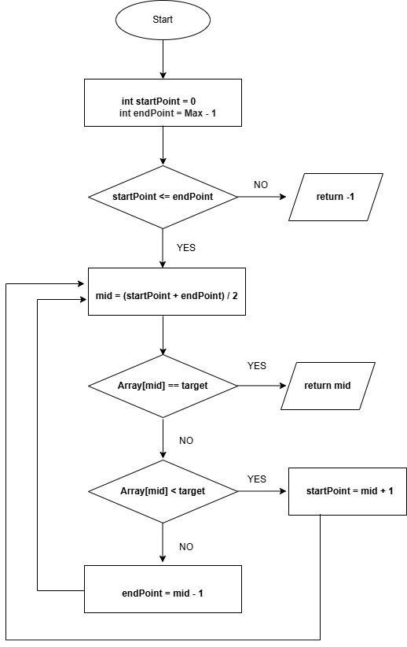
flowchart
Please present this code as a flowchart.

Class Diagram
Hint: Please provide your class in UML
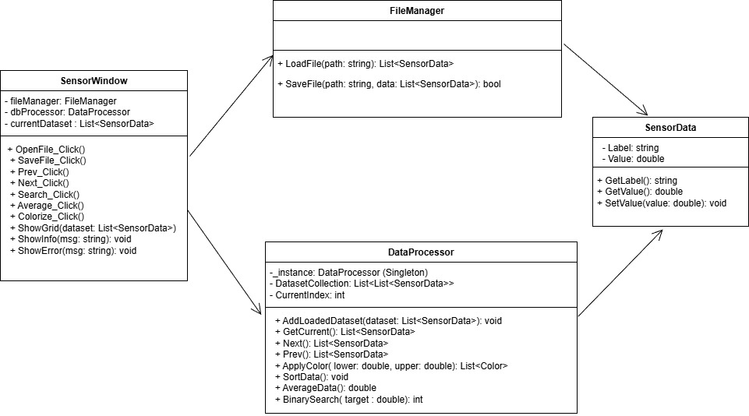
This class diagram is incomplete as it is missing several requirements, including:
- You need a collection of datasets and the ability to move between them.
- No dataset as a 2d array
- No binary search
- Methods like DataAverage() and DataSort() don’t specify which dataset they are operating on.
- There should be a feedback system for giving information to the user when error/action occurs.
Please review the requirements and revise this diagram.

2.4 Programming Methodologies
What are programming paradigms and describe at least two (2) along with the main principles of one (1).
1 | Object-Oriented Programming, OOP  Object-Oriented Programming (OOP) is a programming paradigm that structures software design around objects.  Each object combines its own attributes (data) and functions (methods) into a single unit, which increases code reusability and makes large-scale development and maintenance easier.  Examples: Java, C#, Python, Kotlin  Functional Programming  Functional Programming is a programming paradigm that treats everything as a mathematical function.  It focuses on producing results through pure functions, where data cannot be modified.  This reduces the risk of errors, making the program more stable, and also simplifies testing and debugging.  Examples: JavaScript, Haskell, Scala  Reference  Reference
2 | Main Principles of Object-Oriented Programming (OOP)  Encapsulation: Combines data (attributes) and the methods that manipulate that data within a single class.  Important information is stored inside the object, and only selected parts are exposed to the outside.  The internal implementation and state of the object are kept private to enhance security and prevent data corruption.  Abstraction: Hides complex internal operations and only exposes a simplified interface that is relevant for using other objects.  This makes the development process more efficient and easier to understand.  Inheritance: Allows a child class to reuse and extend the code and properties of its parent class.  This shortens development time and improves code accuracy and consistency.  Polymorphism: Different objects can be processed through the same interface but respond in different ways.  The same method call behaves differently depending on the object’s type, which increases code flexibility and scalability.

Good

2.5 Maintenance and Language Facilities

2.5.1 What are some key aspects of software maintenance?
Provide at least three (3) aspects and include how programming languages support these aspects with built in facilities such as garbage collection releasing memory for the application.
1 | Corrective Maintenance  Corrective maintenance is the process of finding and fixing software errors or problems so that the program operates correctly. Unexpected errors that occur during runtime can affect the stability of the system, so they must be handled quickly. Programming languages support this process through exception handling, allowing the program to continue running safely instead of terminating unexpectedly when an error occurs. This process is essential to ensure stable and reliable system operation.
2 | Perfective Maintenance  Perfective maintenance involves restructuring or improving the software system to enhance its functionality, performance, and stability, and to make it easier to modify in the future. Modern programming languages include features such as garbage collection, which automatically removes unused memory after an operation is completed. This helps the system use memory more efficiently and maintain consistent performance. Through this type of maintenance, the internal quality of the software can be continuously improved.
3 | Adaptive Maintenance  Adaptive maintenance refers to modifying or extending the program’s functionality to respond to changes in hardware, software, user requirements, business needs, or government regulations. For example, when an operating system is upgraded, or a database or hardware platform changes, the program’s code may need to be updated to ensure it continues to work properly in the new environment. Many programming languages support this adaptation through platform independence and standard libraries, which allow programs to run on different operating systems with minimal code changes. For instance, the Java Virtual Machine (JVM) enables Java applications to execute on various platforms without depending on a specific operating system, making maintenance easier when environments change.  Reference

Good

2.5.2 What documentation tool and techniques can be used in software development?
Include at least two (2) techniques and one (1) tool that can be used.
1 | Code Comments  Inline comments are written directly beside or within lines of code to describe what the code does and why it exists. They explain the purpose of functions, methods, parameters, and return values, which makes the code easier for other developers to understand and maintain. Inline comments are especially helpful during code reviews, debugging, and refactoring because they provide clear context and reduce confusion about the logic behind the implementation.
2 | ReadMe Documentation  A README file is a high-level document that provides an overview of the project, including installation instructions, usage guidelines, and contribution rules. It is useful not only for developers but also for end users, as it helps new team members or external contributors quickly understand the purpose and structure of the project. It should clearly describe the project’s goals, technologies used, and version information. A well-written README improves collaboration, communication, and the overall efficiency of project management.
3 | Javadoc  Javadoc is a tool that automatically generates HTML documentation from comments written in Java source code. It allows developers to manage both code and documentation together, ensuring that the generated documentation stays up to date when the source code changes. This automation improves project consistency and makes collaboration between team members easier. Javadoc is widely used in large-scale projects because it simplifies API documentation and helps developers maintain clear, standardized, and professional code documentation.  Reference

Good

2.6 Development Meeting
As with the client meeting, this is where your recommendations must be defended and finalised prior to beginning work on the application. The project plan document must be completed prior to the meeting being held to allow for the approver to understand the planned application and approach.
Item |  | Notes
Summary
Hint: this is the final review prior to development commencing, this should be undertaken prior to any code being created.

Approved By:
Checklist | - Project plan

Task 3: Development Phase

3.1 Code
Once you have been given approval you are able to commence work on the application, any changes to the design of the application must be noted during the development process to ensure that documentation can be updated to reflect the current state of the application when it is delivered and the client can be presented with a lot of changes along with reasoning behind the changes.

3.2 Development adjustments
Please list any changes from the initial design to the application here, this can be populated with git commits.
Change list | Justification
Replaced planned 2D array structure with List<List<SensorData>> | Since each file contains a different number of rows, using a fixed-size 2D array is not flexible enough. To support loading multiple datasets of varying sizes and navigating between them easily, I implemented the structure using List<List<SensorData>> instead. This approach keeps the code simpler, more scalable, and easier to maintain.
Removed SetVlaue() method in SensorData | Since the update feature was not required in the project, the data editing function was not implemented, so the value update method was unnecessary.
Added ClearPreviousUI() method and TextBox.Enter event in SensorWindow | This method was added to clear previous search, average, and color results whenever a new dataset is loaded, to prevent confusion and make the interface easier to use.

Task 4: Testing Phase

4.1 Testing Plan
Thorough testing must be completed prior to handover to the client, this must be broken up into units of work. Adjust the below test plan to suit final application, this application must test the possible user interactions along with validating that the functions are working for edge cases.
- Main window testing must provide screenshots for actual results to validate the pass.
- Function testing must provide trace code screenshots to validate the pass.
Main Window
# | Test | Data | Expected | Actual | Result
1 | File open  (Valid file) | "farm.bin" file | The farm.bin file is displayed in the grid, its name is added to the Loaded list window, and a success message box is shown. | 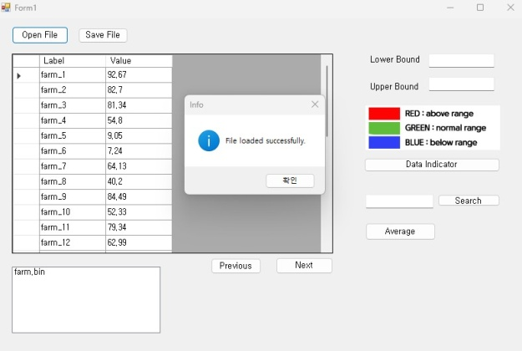 | P
2 | File open  (Duplicate file) | (With the same file loaded)  "farm.bin" file | "This file is already loaded" error message is shown. | 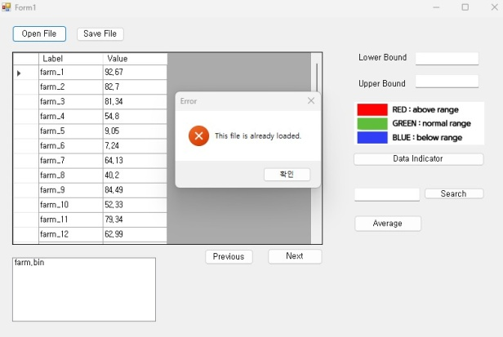 | P
3 | Save without data | null | "No data available to save." error message is shown. | 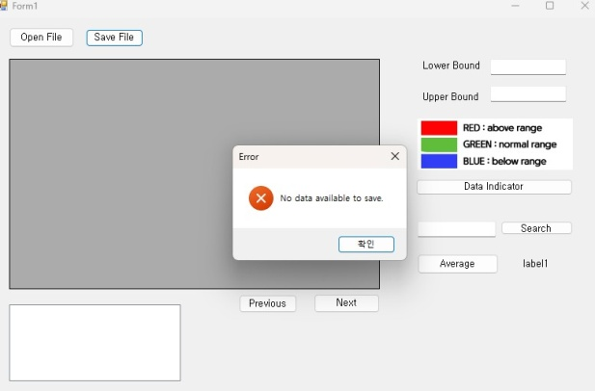 | P
4 | Save with data | farm.bin file  as "farm2" | The file is saved in the .bin file format, and when reopened, it displays the same data as the previous file. | 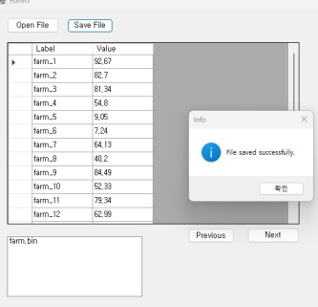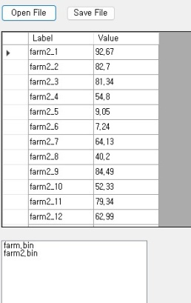 | P
5 | File navigation | Load 4 files | The Next and Previous buttons move through the list of loaded files, updating the grid with the corresponding dataset. | 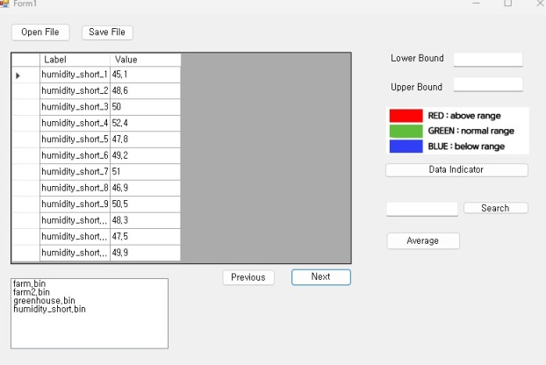 | P
6 | Color Mapping | File:farm2.bin  Lower :50  Upper:80 | The cell colors change: red for data values 80 or above, blue for data values 50 or below, and green for the rest. | 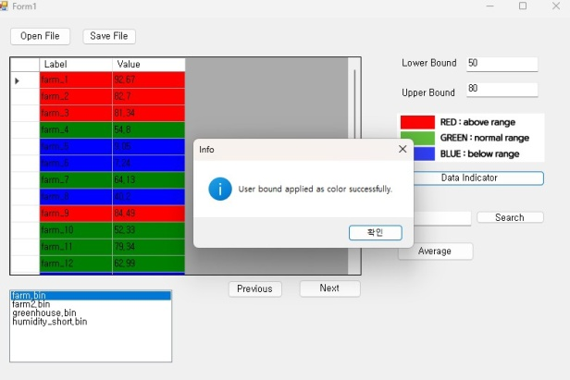 | P
7 | Color Mapping  (String) | Lower :aaa  Upper:80 | The error message "Please enter a valid lower value." is shown. | 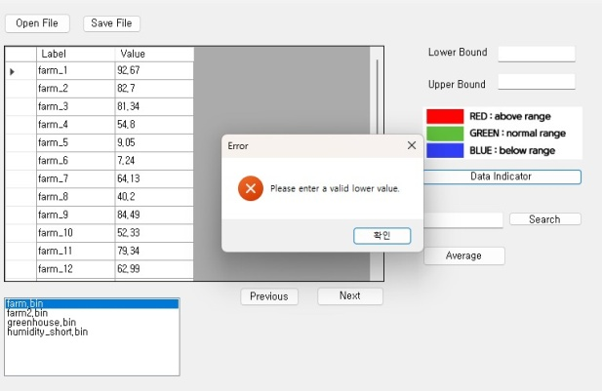 | P
8 | Color Mapping  (Lower> Upper) | Lower :80  Upper:50 | The error message "The lower bound must be less than the upper bound."is shown. | 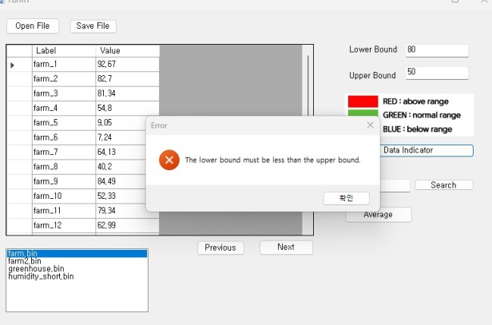 | P
9 | Search | File :farm.bin  Target:54.8 | A "Search successful." message appears, and the searched value is highlighted in the cell. | 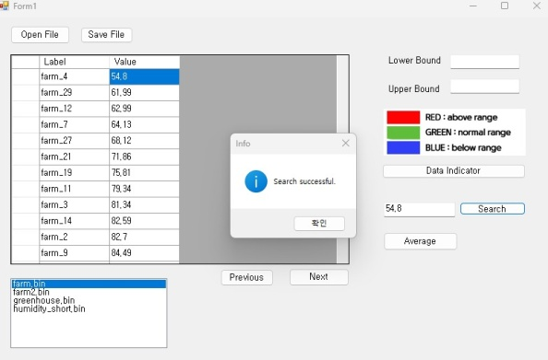 | P
10 | Search  (Non-existent value) | File :farm.bin  Target:1 | The error message "No matching value was found" is shown. | 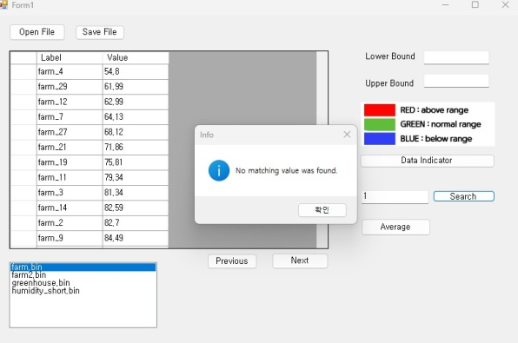 | P
11 | Search  (string) | File :farm.bin  Target:aaa | The error message "Please enter a valid value to search." is shown. | 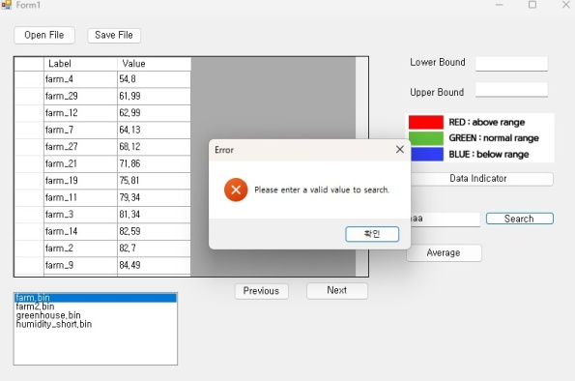 | P
12 | Average | File :farm.bin | A success message appears, and the average value of the currently displayed data is shown on the UI, formatted to three decimal places. | 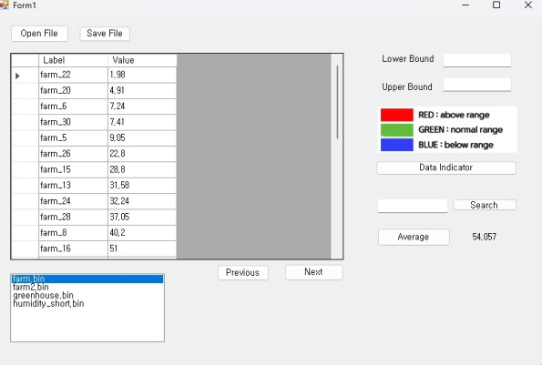  The success message is not shown. | F
13 | Average  Without data | null | The error message "No dataset loaded." is shown. | 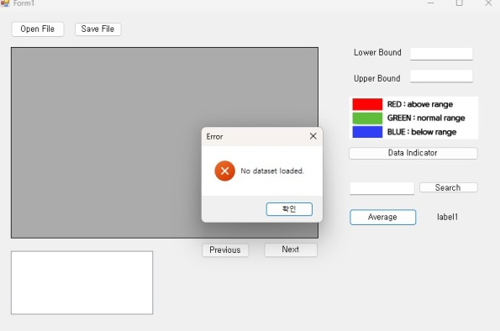 | P
14 | Reset UI | Loading a new file | The new file's data appears in the grid, and all input and output values on the UI are reset. | 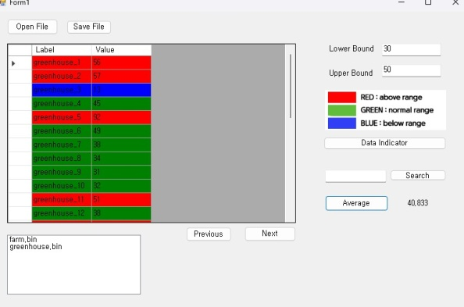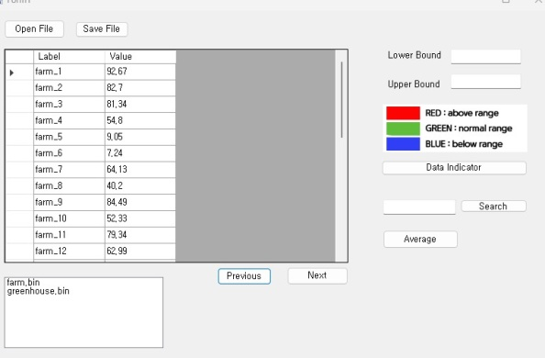

Functions
# | Test |  | Data | Expected | Actual | Result
1 | FileManager.LoadFile | Load:  Farm.bin  (12records)  First label/value:  farm_1/  92.67  last label/value:  farm_12/  62.99 |  | dataSet.Count == 12  First label/value and last label/value in the dataset match the actual data. | 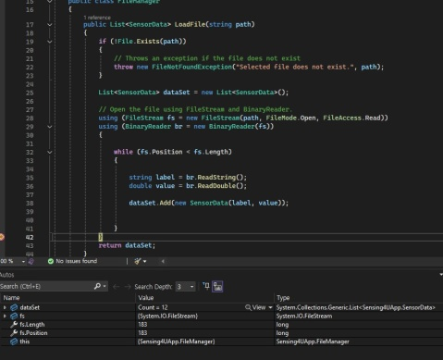  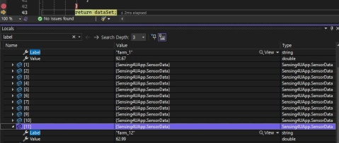 | P
2 | FileManager.SaveFile |  | Load:  Farm.bin  (12records)  First label/value:  farm_1/  92.67  last label/value:  farm_12/  62.99  Save as :  Farm_copy.bin | While saving, the first data item and the last data item written to the file should match the original dataset. | 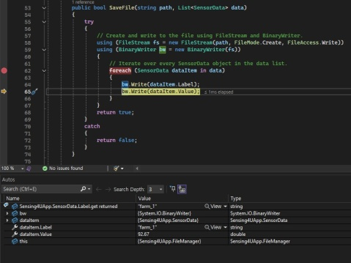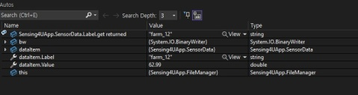
3 | DataProcessor.AddLoadedDatase |  | Load1:  Farm.bin  Load2:  sensorA_mix.bin | Load1:  DatasetCollection.Count == 1  currentIndex == 0  Load2:  DatasetCollection.Count == 2  currentIndex == 1 | 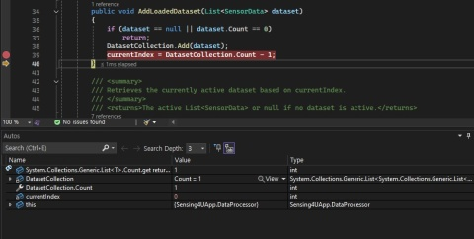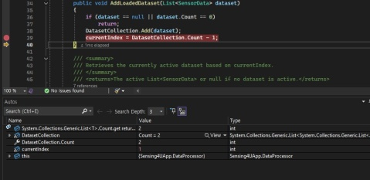
4 | DataProcessor.GetCurrent |  | Load:  Farm.bin | The data displayed in the grid matches DatasetCollection[currentIndex] | 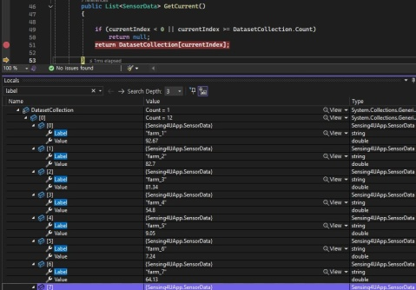
5 | DataProcessor. Prev/Next |  | 3 files loaded in order | Next() increments currentIndex until it reaches the last index, then stays there. Prev() decrements currentIndex until 0, then stays there. | Next: increments currentIndex  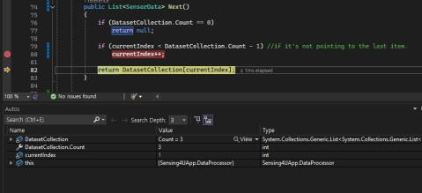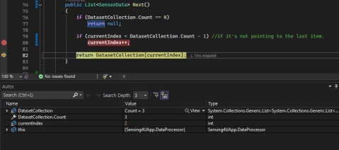  Prev: decrements currentIndex  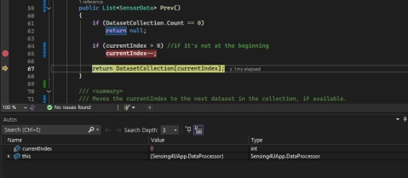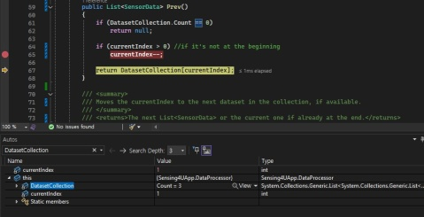
6 | DataProcessor. ApplyColor |  | Load:  Farm.bin  lower=50, upper=80 | color[,] has one row per data row. Values below lower ⇒ Blue,  within range ⇒ Green, above upper ⇒ Red.  color[i,0] values match the expected colors for each case | 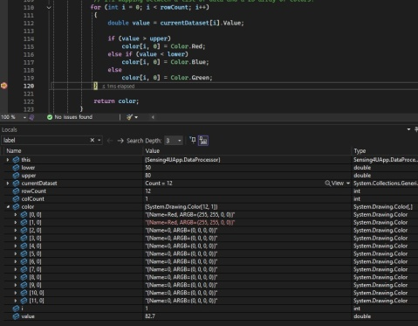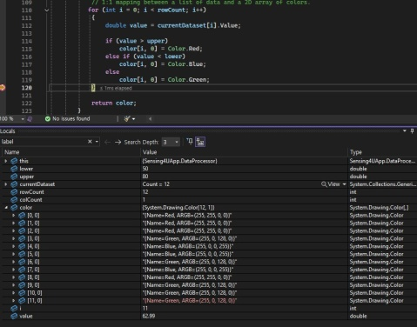
7 | DataProcessor.Sort&BinarySearch |  | Load:  Farm.bin  Target:40.2 | After the sort function breakpoint, the data is sorted, and the target index of the sorted data is passed. | 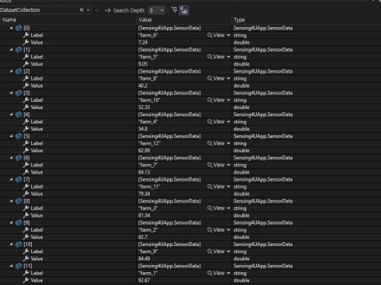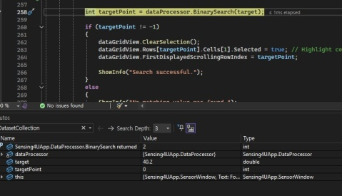
8 | DataProcessor.AverageData |  | Load:  Farm.bin  Dataset sum : 711.28000 | count == 12  sum == 711.28000  result == 59.27333 | 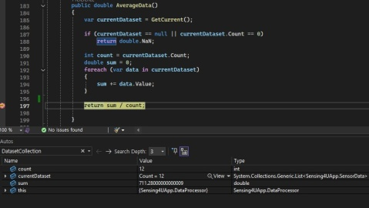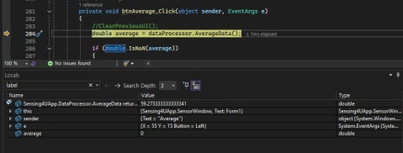

4.2 Debugging Tools and Methodologies
List at least three (3) debugging methods or tools that can be used to assist in the testing of a software application.
1 | Backtracing  Backtracing, also known as backward debugging, is a technique used to find the root cause of a problem by starting from the point where the issue first began and working backward through the code. This procedure is particularly useful when dealing with complex issues that are difficult to trace forward, as it helps determine how and why a problem manifested by reversing the execution path.
2 | Logging Technique  Logging is a method utilized in debugging that involves recording events and variable values that occur during program execution. Developers can insert commands like “Log.d()” or “System.out.println()” into the code to track the execution flow, allowing them to analyse the logs and pinpoint the cause when an error occurs. Logging provides useful information even when problems are difficult to reproduce, especially in complex applications or scenarios where behaviour changes based on user input.
3 | Breakpoints and Stepping  Breakpoints and Stepping are fundamental debugging techniques used within a software development environment (IDE). Setting a breakpoint at a specific line of code temporarily stops the program's execution at that exact point. Once paused, the Stepping feature allows the developer to move through the code either one line at a time (step-over) or by diving into a function (step-into). This process enables the developer to observe the program's internal flow, including the current values of variables, the memory state, and the function call stack. This direct observation is essential for effectively pinpointing the precise location and cause of any errors.  Reference

4.3 Testing Procedures
List at least three (3) testing procedures that can be used within software development.
1 | Unit Testing  Unit Testing focuses on verifying that the smallest individual components of the software, such as single functions (methods) or classes, are working correctly in isolation. The primary goal is to catch and fix defects early in the development process, which significantly helps improve the overall reliability of the code. Unit tests are generally written by the developers themselves and are performed in an isolated environment, meaning they aren't influenced by external factors like databases or files. For instance, testing whether a specific average calculation function consistently returns the correct value when given a certain set of data is a common example of unit testing.
2 | Integration Testing  Integration Testing is a procedure in software development that involves combining two or more individually tested modules or components to verify issues that arise when they interact. The main goal of this testing is to confirm that the interfaces and data flow between the modules are operating correctly as designed. Specifically, it ensures that errors (such as data corruption or incomplete communication) do not occur when data or control is passed from one module to another. This process plays a critical role in confirming that the entire system has been stably and reliably integrated.
3 | System Testing  System Testing is the final stage of verification performed on the entire, fully integrated software system after all individual modules have been put together. The main purpose is to comprehensively ensure that the software meets all functional and non-functional requirements (such as performance, security, and user interface) that were initially defined. System tests are carried out under conditions similar to the actual operating environment, focusing on validating the entire system's performance from an end-user perspective. This final step is crucial for determining if the completed product meets the necessary release criteria for deployment.  Reference

Task 5: Review Phase

5.1 Handover
With testing complete the client needs to have the application demonstrated prior to submission, they are curious to possible extensions discovered during the development process for the MVP and would like feedback on the limitations and restrictions currently present with the application.
The client would also like external documentation to be generated and presented for review. Documentation should take the form of a report that contains:
- Application name,
- Introduction outlining the intent of the application,
- SDLC used,
- Requirements,
- Any features implemented,
- How to guide for the features,
- Commit history.
Lessons Learned
Limitation |  | Notes
Recommendation
Feedback
Hint: this should be capable of being implemented within the next two (2) development cycles

Presented to:
Checklist | - Zipped source code,  - Internal documentation,  - Screenshot of client meeting email,  - Handover documentation  - Scope of work,  - Project plan,  - This document.

End of Assessment Task One

